v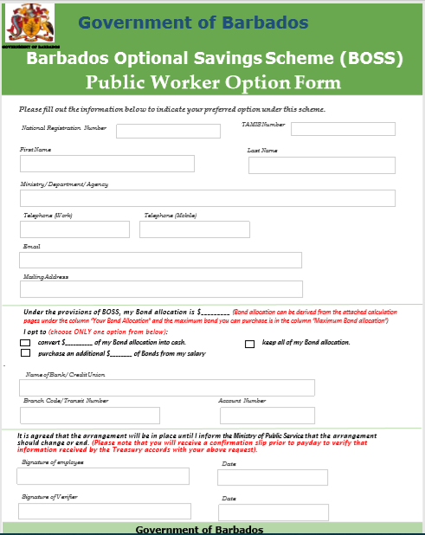 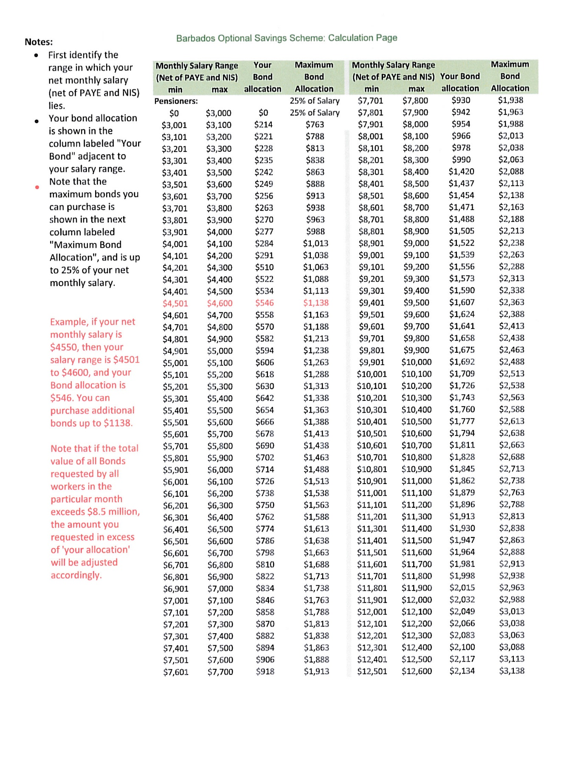 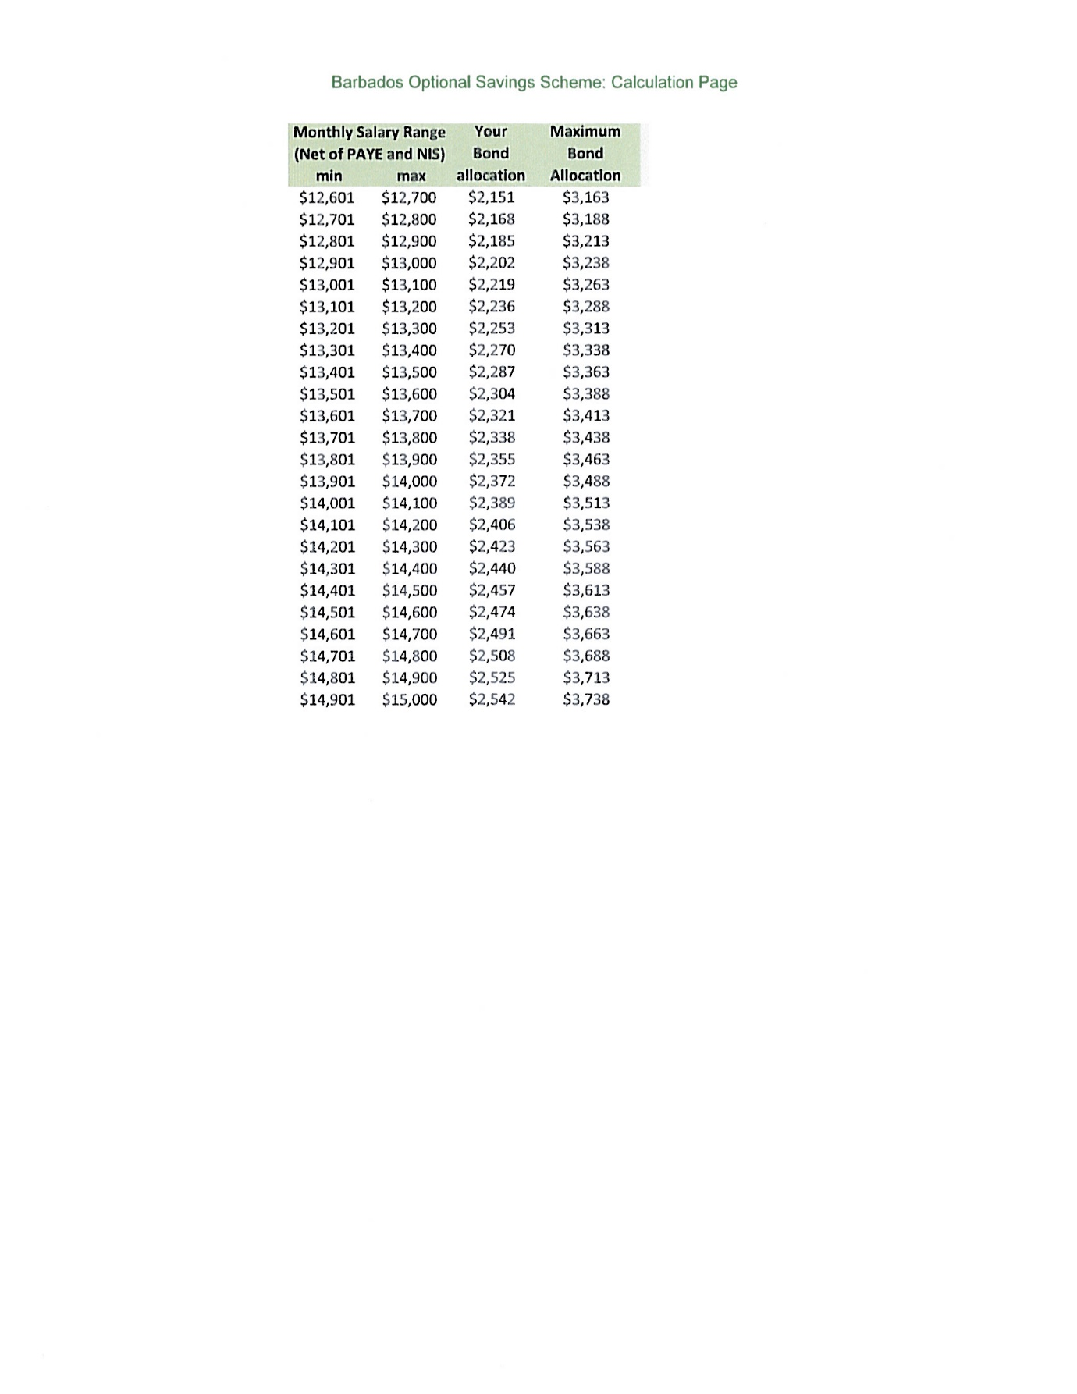

Your Verifier may be ….

**Guidelines for Completing the BOSS Form**

Enter your personal information including your National Registration Number and your TAMIS Number.

Enter your contact information.

Enter your email address.

Enter your BOSS Allocation here. See the Help Sheet for a guide on identifying your BOSS Allocation.

Place a ✓ tick in the appropriate box to indicate your BOSS option.

Enter your $______ in the appropriate space. See the Help Sheet for a guide on selecting your options.

Enter your signature and the current date